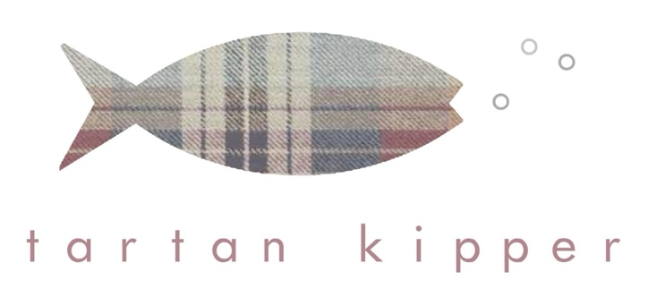
Returns & Refund Policy
Last updated: March 4th 2026
We want you to love your purchase. If you are not completely satisfied, you may return your item under the following conditions:

1. Your Right to Cancel (Online Orders)
Under UK Consumer Contracts Regulations, you have the right to cancel your order within 14 days of receiving your goods.
You then have a further 14 days to return the item to us.

2. Condition of Returns
Items must be:
- Unused and in original condition
- In original packaging
- Returned with proof of purchase
We reserve the right to refuse a refund if items are not returned in a resaleable condition.

3. Non-Returnable Items
The following items cannot be returned unless faulty:
- Personalised or custom-made gifts
- Perishable goods
- Earrings (for hygiene reasons)

4. Refunds
Once we receive and inspect your return, we will issue a refund within 14 days using your original payment method.
Original delivery costs will be refunded (standard delivery only). Return postage costs are the responsibility of the customer unless the item is faulty.

5. Faulty or Damaged Items
If your item arrives damaged or faulty, please contact us within 48 hours of delivery with photos, and we will resolve the issue promptly.

